**Maximum power extraction of wind Energy using Artificial Neural Network (ANN)**

**A thesis is submitted in partial fulfillment of the requirement for the degree**

**of**

**Bachelor of Science in Electrical and Electronic Engineering**

**Supervised By**

**Mr.M.M. Atiqur Rahman**Assistant Professor

Department of Electrical and Electronic Engineering

Ahsanullah University of Science and Technology

**A drawing of a cartoon character

Description generated with high confidence  
  
Submitted By**

**Mahmudul Hasan Sourav 14.01.05.109  
Sami Patwary 14.01.05.117  
Saraf Wasima 14.01.05.120   
Ridwan Islam Chowdhury 14.01.05.128  
Kamrul Hasan Safin 14.01.05.129  
   
APPROVAL**

The thesis titled **“Maximum power extraction of wind Energy using Artificial Neural Network (ANN)”** submitted by the group, Session: April 2017, consisting of the following five students has been accepted as satisfactory in partial fulfillment of the requirement for the degree of Bachelor of Science in Electrical and Electronic Engineering.

**Supervisor**

………………………………………....  
**Mr.M.M. Atiqur Rahman**Assistant Professor

Department of Electrical and Electronic Engineering  
Ahsanullah University of Science and Technology

141-142, Love Road, Tejgaon Industrial Area, Dhaka-1208

**DECLARATION**

It is hereby declared that, except where specific reference are made to other investigations, the work embodied in this thesis is the result of investigation carried out by the authors under the supervision of **M.M. Atiqur Rahman,** Assistant Professor, Department of Electrical and Electronic Engineering, Ahsanullah University of Science and Technology. This thesis or any part of it has not been submitted elsewhere for the award of any degree, diploma or other qualification except for publication.

**Signature of group members:**

……………………………………… Date:……………….…

Mahmudul Hasan Sourov

**Student ID:** 14-01-05-109

……………………………………… Date:……………………

Sami Patwary

**Student ID:** 14-01-05-117

……………………………………… Date:……………………

Saraf Wasima

**Student ID:** 14-01-05-120

……………………………………… Date:……………………

Ridwan Islam Chowdhury

**Student ID:** 14-01-05-128

……………………………………… Date:……………………

Kamrul Hassan Safin

**Student ID:** 14-01-05-129

**Dedicated to**

Our parents and honorable supervisor, Mr. M.M. Atiqur Rahman. Without your support and inspiration, this would not have been possible.

**CONTENTS**

**Chapter 1: Introduction**

1. Introduction……………………………………………………………..…….………16

1.1 What is wind energy?.................................................................................17

1.2 Structure of a Wind Turbine……………………………………….……….17

1.2.1 The conversion of Wind into electricity………..…….………18

1.2.2 Advantages of wind energy…………………………………..18

1.2.3 Challenges of Wind Energy…………………………..………20  
1.2.4 Maximum Power Point Tracking……………………..………...21

1.3 Comparison of Different MPPT method…………….……………….….……23

1.4 Thesis Objective…………...……………………….…………….,…………..25

**Chapter 2 : Literature Survey**

2.1 Renewable Energy and Electricity…………..……….……..……..…………..26

2.2 Wind Energy Conversion……………………..…………....…………………27

2.2.1 Electricity Generation………………………....………..……….29

2.2.2Environmental and Social Impacts…..….…..…….…………….29

2.3 Wind Turbine Development and Types of Turbines ……..……..……………30

2.3.1 Wind Turbine History…………………………………………30

2.3.2 Wind Turbine…………….………………………………….....32

2.3.3Types of Wind Turbines.….……………………………………32

**Chapter 3 : Artificial Neural Network**

3.1 Introduction…………………………………………………………………….36

3.2 Historical background……...…………...………………..…………………….37

3.3 Mechanism of ANN………….…..………………………...………………….39

3.4 Advantages of Artificial Neural Networks ( ANN)……..........……..………...42

3.5 Applications of neural networks……………………………..…………….….43

**Chapter 4: Feed Forward Back Propagation process**

4.1 Neural Network Structure……..…...……………………..……………..……45

4.1.1 Single Layer Feed Forward Network……...………………..…45

4.1.2 Multilayer Feed-forward Neural Networks……..….………….45

4.1.3 Radial Basis Function Neural Networks…...……….…………45

4.1.4 Recurrent Neural Networks…………...……………………….46

4.2 Multilayer feed forward system…………...…………….……………………47

4.3 Multi-Layer Feed Forward Process…….……..……….……………………..48

4.4 Transfer(Activation) Function…….…………………….…………………....49

4.4.1 Sigmoid function………………….…….…………………..…49

4.5 Back propagation process………………………………………........…..50

4.6 Gradient Descent Method…………………………….………….……….51

4.6.1 Gradient Descent Method Adjusting weights using derivative …………………meth……………………………………………………...…52

4.6.2 Adjusting Weights………………………..……………54

**Chapter 5 : Implementation Of ANN algorithm**

5.1 Wind Velocity Estimation by ANN 1…..…………………….………….…..55

5.2 Estimated wind speed determination…………..……...………………….….56

5.3 Optimal rotor speed Estimation by ANN 2…….……….….……..………….56

5.4 Estimate optimal rotor speed determination………..…..……….…....………57

5.5 Final implementation…….….…..…………………..………….…………….57

5.6 Regression Analysis of ANN 1………….….………….………………….…58

5.7 Regression Analysis of ANN 2………….…………………………..………59

5.8 Validation Performance……………..……………………………………….60

**Chapter 6 : Results and Discussions**

6.1 Wind speed Estimation Under Rapidly Changing wind conditions……….62

6.2 Wind Speed Error………………………………………………………….63

6.3 Optimal Rotor Speed Estimation………………………..………………...64

6.4 Rotor Speed Error……………….………………………………………...65

**Chapter 7: Conclusion**

1. Conclusion………………………………………….……………………….66

**List of Tables**

**1.1** Comparison of Different methods of MPPT…………….……………………**25**

**List of Figures**

1.1 Wind Energy Plant……………………………………………………………….16

1.2 Wind formation from cool air blow into warm air……………………………….17

1.3 Speed vs. power output characteristics of a wind turbine…………………………...22

###### 1.4 Maximum power point tracking……………………………………………………..23

2.1 Schematic overview of a wind turbine………………………………………….….27

2.2 World’s cumulative installed wind power capacity during 1991-2012…………..30

2.3 Continents’ share of wind power capacity during 2002-2012……………………31

2.4 Top 12 countries with the largest annual wind power capacities during 2007-2012 ………………………………………………………………………………………….31

2.5 Two types of Wind Turbines……………………………………………………33

3.1 Depicting the different layers of a neural network………………………...………..40

4.1 Multi-Layer system………………………………………………………………….47

4.2 Feed Forward Process……………………………………………………………….48

4.3 Sigmoid Function Graph (showing range)……………………………………..…49

**4.4: Back propagation system…………………………………………………………50**

**4.5: Error VS Random weight order graph……………………………………………51**

**.**

**4.6: Derivative Method………………………………………………………………..52**

**4.7: Derivative Method………………………………………………………………..52**

**4.8: Gradient Descent method using Derivative……………………………………….53**

5.1 Wind velocity estimation by ANN 1………………………………………………..55

5.2 optimal rotor speed estimation by ANN 2…………………………………………..56

5.3 Proposed ANN based MPPT controller……………………………………………..57

5.4 Regression Analysis of ANN 1……………………………………………………...58

5.5 Regression Analysis of ANN 2……………………………………………………...59

5.6 Validation performance……………………………………………………………..60

6.1 Original and estimated wind speed………………………………………………….62

6.2 wind speed error……………………………………………………………………..63

6.3 Original and Estimated Rotor speed…………………………………………………64

6.4 Rotor speed error…………………………………………………………………….65

**ACKNOWLEDGEMENT**

**We would like to express our deepest gratitude to the Almighty. for giving us the ability to successfully complete the thesis.  
  
We express our deepest gratitude to our honorable thesis supervisor Mr. M M Atiqur Rahman, Assistant Professor. Dept. of Electrical and Electronic Engineering, Ahsanullah University of Science and Technology for his invaluable time and patience in answering all our queries no matter how trivial or major they were. He was always there giving us his endless guidance. productive criticisms and thoughtful advices throughout our thesis journey. Without his guidance and help, we would not have been able to complete our thesis.  
  
 We would like to end by thanking each other for making this thesis a very Interesting journey. Without each other’s support we would not have been able to complete this thesis.  
  
  
Thank you.**

**Abstract**The efficiency of the wind turbine system depends on how accurately the maximum power point can be tracked. To achieve maximum power the rotor should always rotate at certain desired optimal speed corresponding to a wind speed. An artificial neural network (ANN) based maximum power point tracking (MPPT) algorithm has been developed. The proposed ANN based controller has the ability to estimate wind speed by tracking the maximum power point (MPP) and the optimal rotor speed with very low error compared to the conventional MPPT methods. The algorithm is based on two series neural networks. ANN1 for wind speed estimation and ANN2 for optimal rotor speed estimation. The method demonstrates remarkable performance in estimating wind speed under rapidly changing wind conditions and also shows outstanding performance in estimating optimal rotor speed corresponding to a particular wind speed. This optimal rotor speed extracts the maximum power of the system for that particular wind speed. Nonlinear time domain simulations have been carried out to validate the effectiveness of the proposed controllers in terms of wind speed estimation and MPPT under different operating conditions. Simulation results confirm the effectiveness of the MPPT controller in tracking the maximum power point under rapidly changing wind conditions.

**Chapter 1  
  
Introduction**

**Modern days there are massive demand of power supply across the globe. Most of which are fulfilled using traditional and conventional methods. These methods have adverse effect on the environment and we also cannot rely on them as their supply is not unlimited. So, in recent times search for clean energy has got very high priority. Renewable energy is one of the best sources of clean energy that have a very low environmental impact compared to the traditional energy sources.  
Wind, solar, tidal wave, geothermal, bio fuels are noteworthy renewable energy sources. One of the easily available renewable source is wind energy. wind energy plants require less operational and maintenance cost. The amount of power output from a wind energy conversion system (WECS) depends on the accuracy with which the peak power points are tracked by the maximum power point tracking (MPPT) controller of the wind energy conversion system.**

A windmill on a cloudy day

Description generated with very high confidence  
 Figure 1.1: Wind Energy Plant

#### Since the efficiency of the wind turbine system depends on how accurately the maximum power point can be tracked, the determination of the optimum speed for varying wind conditions is very important. We will be using Artificial Neural Network (ANN) to find out the optimum rotor speed, which will eventually extract maximum power output at various wind speed.

1.1 What is wind energy? :

Wind energy is a type of energy used to make electricity, like fossil fuels or nuclear power. Wind energy harvests energy from the wind and converts it into electrical power. Wind is created by temperature changes in the atmosphere. As warm air rises, cool air moves into the area, and the movement creates what we know as wind. Below is a diagram showing the process of wind formation over a body of water, a common place for wind energy to be harvested.

A picture containing object

Description generated with high confidence  
  
  
Figure 1.2: Wind formation from cool air blow into warm air

1.2 Structure of a Wind Turbine:

A wind turbine is composed of propellers-like blades called a rotor. The rotor is attached to a tall tower. On average wind towers in residential settings are about 20m high [16]. The reason of the tower being so tall is that the winds are stronger higher from the ground. A wind turbine captures the wind to produce energy, the wind makes the rotor spin; as the rotor spins, the movement of the blades drives a generator that creates energy. The motion that causes the turbines to rotate is called kinetic energy.

1.2.1 The conversion of Wind into electricity:

Wind power is converted into electricity by magnets moving past stationary coils of wire known as the stator. As the magnets pass the stator, AC electricity is produced. It is then converted into DC electricity which can be used to charge batteries which store the electrical energy or can also be fed into a grid interactive inverter for feeding power into the electricity grid [16].

1.2.2 Advantages of wind energy:

1. Renewable and sustainable:

Wind energy itself is both renewable and sustainable. The wind will never run out, unlike the earth’s fossil fuel reserves (such as coal, oil and gas), making it the ideal energy source for a sustainable power supply.

2. Environment Friendly:

Wind energy is one of the most environmentally friendly energy sources available today. After the manufacture and installation of wind turbines, there will be little to no pollution generated as a result of the wind turbines themselves.

Wind turbines produce no greenhouse gases such as carbon dioxide (CO2) or methane (CH4) which are both known to contribute towards global warming.

It should be noted that noise and visual pollution are both environmental factors, but they don’t have a negative effect on the earth, water table or the quality of the air we breathe.

**3. Reduces Fossil Fuel Consumption:**

Generating electricity from wind energy reduces the need to burn fossil fuel alternatives such as coal, oil and gas. This can help to conserve dwindling supplies of the earth’s natural resources, allowing them to last longer and help to support future generations.

**4. Wind Energy is Free:**

Unlike some other energy sources, wind energy is completely free. There’s no market for the supply and demand of wind energy, it’s there to be used by anyone and will never run out. This makes wind energy a viable option for generating cheap electricity.

**5. Small Footprint:**

Wind turbines have a relatively small land footprint. Although they can tower high above the ground, the impact on the land at the base is minimal. The area around the base of a wind turbine can often be used for other purposes such as agriculture.

**6. Industrial & Domestic Installations:**

Wind turbines are not just limited to industrial-scale installations such as wind farms. They can also be installed on a domestic scale, with many landowners opting to install smaller, less powerful wind turbines in order to provide part of a domestic electricity supply. Domestic wind turbines are often coupled with other renewable energy technologies such as solar panels or geothermal heating systems.

**7. Remote Power Solution:**

Wind turbines can play a key role in helping to bring power to remote locations. This can help to benefit everything from a small off-grid village to a remote research station.

**8. Wind Technology Becoming Cheaper:**

The first ever electricity-generating wind turbine was invented in 1888 [17] .Since then, wind turbines have improved significantly and nowadays the technology is beginning to come down in price, making it much more accessible.

Government subsidies are also helping to reduce the cost of a wind turbine installation, with many governments across the world providing incentives for not only the installation of such technologies, but also for the ongoing supply of environmentally friendly electricity.

**9. Low Maintenance:**

Wind turbines are considered relatively low maintenance. A new wind turbine can be expected to last some time prior to any maintenance work needing to be carried out. Although older wind turbines can come up against reliability issues, each new generation of wind turbine is helping to improve reliability.

**10. Low Running Costs:**

As wind energy is free, running costs are considered low. The only ongoing cost associated with wind energy is for the maintenance of wind turbines, which are considered low maintenance in nature anyway.

**11. Huge Potential:**

Wind energy has huge potential. It’s both renewable and sustainable and is present in a wide variety of places. Although a significant level of wind energy is required to make a wind turbine installation cost effective, the technology is not limited to just a handful of locations such as is the case for geothermal power stations.

**12. Increases Energy Security:**

By using wind energy to generate electricity, we are helping to reduce our dependency on fossil fuel alternatives such as coal, oil and gas. In many cases, these natural resources are often sourced from other countries.

War, politics and overall demand often dictate the price for natural resources, which can fluctuate and cause serious economic problems or supply shortages for some countries. By using renewable energy sources, a country can help to reduce its dependency on global markets and thus increase its energy security.

**13. Job Creation:**

The wind energy industry has boomed since wind turbines first became available on the market. This has helped to create jobs all over the world. Wind sector employed more than 100,000 workers in 2016, and wind turbine technician is one of the fastest growing American Jobs of the decade. According to the wind vision report, wind has the potential to support more than 600,000 jobs in manufacturing, installation, maintenance and support services by 2050 [18].  
  
  
1.2.3 Challenges of Wind Energy:

1. **The Wind Fluctuates:**

Wind energy has a similar drawback to solar energy in that it is not a constant energy source. Although wind energy is sustainable and will never run out, the wind is not always blowing. This can cause serious problems for wind turbine developers who will often spend significant time and money investigating whether or not a particular site is suitable for the generation of wind power.

For a wind turbine to be efficient, the location where it is built needs to have an adequate supply of wind energy. The average wind speed needs to be above 5m/s [16]. This is why we often see wind turbines built on top of hills or out at sea, where there are less land obstacles to reduce the intensity of wind energy.

**2. Installation is Expensive:**

Although costs are reducing over time, the installation of a wind turbine is considered expensive.

Small scale wind turbines under 100KW costs roughly $3000 to $8000 per KW of capacity. A 10kw machine (the size needed to power a large home) might have an installed cost of $50,000-$80,000.

The cost for a utility scale wind turbine ranges from about $1.3-$2.2 million per MW. Most of the commercial-scale turbines installed today are 2MW in size and cost roughly $3-$4 million [19].

**3. Threat to Wildlife:**

It is widely reported that wind turbines pose a threat to wildlife, primarily birds and bats. It is however believed that wind turbines pose less of a threat to wildlife than other manmade structures such as cell phone masts and radio towers. Nevertheless, wind turbines are contributing to mortality rates among bird and bat populations.

**4. Noise Pollution:**

One of the most popular disadvantages of wind turbines is the noise pollution that they generate. A single wind turbine can be heard from hundreds of meters away. Combine multiple wind turbines and the audible effects can be much greater.

The closest that a wind turbine is typically placed to a home is 300 meters or more. At that distance, a turbine will have a sound pressure level of 43 decibels. At 500 meters that sound pressure level drops to 38 decibels [20].  
  
**5. Visual Pollution:**

Another widely reported disadvantage of wind turbines is visual pollution. Although many people actually like the look of wind turbines, others do not and see them as a blot on the landscape. This tends to come down to opinion, and as more wind farms are built, public acceptance is becoming commonplace.

**1.2.4 Maximum Power Point Tracking:**

Maximum power point tracker(MPPT) extracts maximum power from the wind turbine from cut-in to rated wind velocity by sensing only dc link power. It is also used with PV solar system.

A close up of a map

Description generated with high confidenceElectric generator is used with wind turbine which converts mechanical energy into electrical energy. Electrical energy production mainly depends on the availability of the wind. With the variation of wind speed electric energy production can be increased or decreased.   
Figure1.3: Speed vs. power output characteristics of a wind turbine.  
   
The wind turbine mechanical output is related to the wind speed Vw and can be expressed as,

Pm = ρACpVw3

Where ƿ is the air density and A is swept area by the turbine blades, Vw is the velocity of wind. As the swept area increases, the power also increases, so the higher area machines give more power than the lower ones.  
The wind power captured by the wind turbine depends on the power co-efficient(Cp) expressed as,

.5176 - 0.4 -5) + 0.0068

-

Here is the tip speed ratio and , is the blade pitch angle. The value of can be calculated by using the following relationship,

We cannot convert all the wind energy into electrical energy; we can convert only 48% according to Betz limit. MPPT’s function is to extract the maximum out of the generator. With the changing wind velocity, it tracks the maximum point for a particular wind speed. It also shows the non-linear characteristics of wind energy system. In figure solid non-linear curves indicates the maximum possible power line for particular wind speed.

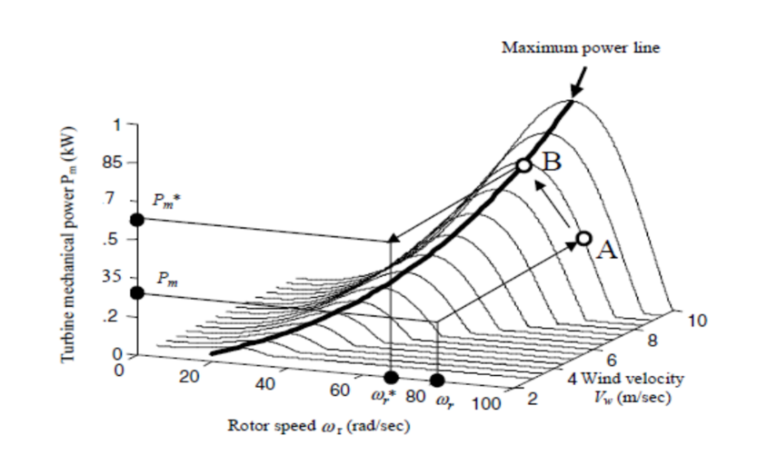The maximum power point tracking concept is illustrated clearly in Figure 1.2. It can be observed that the maximum power which can be captured at different wind speeds vary along the solid-line shown in the figure .For example for a particular wind speed, B represents the maximum power while the corresponding rotor speed is ωr* at point B. The tracking problem is to find the optimum speed tor which will yield power Pm* at a certain wind speed V. The artificial neural network is employed in this work to dete9rmine wind speed Vw and optimum turbine speed ωr* from the measurement of   
power.

###### Figure 1.4: Maximum power point tracking

**1.3 Comparison of Different MPPT method:**

1. **Tip speed ratio:**

The tip speed ratio is given by diving the speed of the tips of the turbine blades by the speed of the wind. The optimum tip speed ratio depends on the number of the of blades in wind turbine rotor. The fewer the number of blades, the faster the wind turbine rotor needs to turn to extract maximum power from the wind. A two bladed rotor has a TSR of around six, three bladed rotor around five, four bladed rotor around 3. If the TSR is too low the turbines will stall, if TSR is too high it will pass through turbulent air and power will not be optimally extracted from the wind [21].

1. **Online Method:**

In online methods, also known as model free methods, usually the instantaneous values of the PV output voltage or current are used to generate the control signals. The online methods Perturbation and Observation (P&O), as well as the incremental conductance method(IncCond) will be reviewed.

1. **Perturb and observe:**

In this method the controller adjusts the voltage by a small amount for the array and measures power, if the power increase further adjustment in that direction are tried until power no longer increase. This is called the perturb and observe method and is most common, although this method can result in oscillation of power output. It is referred to as a hill climbing method, because it depends on the rise of the curve of power against voltage below the maximum power point and the fall above the point. Perturb and Observe method may result in top level efficiency, provided that a proper predictive and adaptive hill climbing strategy is adopted [22].

1. **Artificial Neural Network (ANN):**

Artificial neural network is a computing system vaguely inspired by the biological neural networks that constitute animal brain. An ANN is based on a collection of connected units or nodes called artificial neurons. Each connection between artificial neurons can transmit a signal from one to another. In common ANN implementation, the signal at a connection between artificial neurons is a real number and the output of each artificial neuron is calculated by a non-linear function of the sum of its inputs. Artificial neurons and connections typically have a weight that adjusts as learning proceeds. The weight increases or decreases the strength of a signal at a connection. It is organized in layers. Different layers perform different kinds of transformation on their inputs. Signals travel from the first to the last layer, possibly after traversing the layers multiple times [22].

1. **Fuzzy Logic:**

It has 4 main parts – Fuzzification module, Knowledge base, Inference base, Defuzzification module.

Fuzzification module transforms the system inputs which are crisp numbers, into fuzzy sets.

Knowledge base stores if then rules provided by the experts.

Inference base simulates the human reasoning process by making fuzzy interference on the inputs and IF-THEN rules.

Defuzzification module transforms the fuzzy sets obtained by the interference engine into crisp value [23].

**TABLE:1.1 Comparison of Different methods of MPPT:**

|  |  |  |  |
| --- | --- | --- | --- |
| Serial no. | MPPT methods | Accuracy | Sensed Parameter |
| 1. | Fuzzy Logic | High | Depends |
| 2. | ANN | High (98%) | Depends |
| 3. | P&O (fixed perturbation size) | Low | Voltage and Current |
| 4. | P&O (variable perturbation size) | High (96%) | Voltage and Current |
| 5. | Tip Speed Ratio | Low | Wind Speed |

**1.4 Thesis Objective:**

* To estimate wind speed using Artificial Neural Network (ANN).
* To estimate optimal rotor speed for extracting maximum power using ANN.

**Chapter2**

**Literature Survey**

**2.1 Renewable Energy and Electricity**

As electricity demand escalated, with supply depending largely on fossil fuels plus some hydropower and then nuclear energy, concerns arose about carbon dioxide emissions contributing to possible global warming. Attention again turned to the huge sources of energy surging around us in nature – sun, wind, and seas in particular. There was never any doubt about the magnitude of these, the challenge was always in harnessing them so as to meet demand.

Today we are well advanced in meeting that challenge, while also testing the practical limits of doing so. Wind turbines have developed greatly in recent decades, solar photovoltaic technology is much more efficient, and there are improved prospects of harnessing the energy in tides and waves. Solar thermal technologies in particular (with some heat storage) have great potential in sunny climates. With government encouragement to utilize wind and solar technologies, their costs have come down and are now in the same league per kilowatt-hour as the increased costs of fossil fuel technologies, especially with likely carbon emission charges on electricity generation from them.

The World Energy Outlook 2016 (WEO2016) makes the points that wind and solar PV have five technical properties that make them distinct from more traditional forms of power generation. First, their maximum output fluctuates according to the real-time availability of wind and sunlight. Second, such fluctuations can be predicted accurately only a few hours to days in advance. Third, they use devices known as power converters in order to connect to the grid (this can be relevant in terms of how to ensure the stability of power systems). Fourth, they are more modular and can be deployed in a much more distributed fashion. Fifth, unlike fossil fuels, wind and sunlight cannot be transported, and while renewable energy resources are available in many areas, the best resources are frequently located at a distance from load centers thus, in some cases, increasing connection costs.

According to WEO2016, high levels of variable renewables (wind and solar) “will require significant enhancement of system integration measures.” These measures include flexible power sources such as hydro and open cycle gas turbines, demand-side measures, electricity storage, strong and smart transmission and distribution grids. The costs of all these, over and above the generation costs, are often referred to as system costs. Grid-level system costs for variable renewables are large ($15-80/MWh) but depend on country, context and technology (onshore wind < offshore wind < solar PV).

A further aspect of considering sources such as wind and solar in the context of grid supply is that their true capacity is discounted to allow for intermittency. In the UK this is by a factor of 0.43 for wind and 0.17 for solar PV, hence declared net capacity (DNC) is the figure used in national reporting – “the nominal maximum capability of a generating set to supply electricity to consumers.” It has a considerable effect on published load and capacity factors [1].

**2.2 Wind Energy Conversion**

Wind turbines - also called Wind Energy Conversion (WEC) systems - harness the kinetic energy of wind and convert it into mechanical energy and then electricity (IPCC, 2012, p. 550; IEA-ETSAP & IRENA, 2016, p. 8). Often, a number of wind turbines are grouped together and, along with roads, buildings, and the grid connection point, they form a wind farm that can have a capacity of more than 100 MW. Wind farms can be realized on- or off-shore (Kosmadakis et al., 2013, p. 13; Reuter & Elsner, 2016, p. 10)

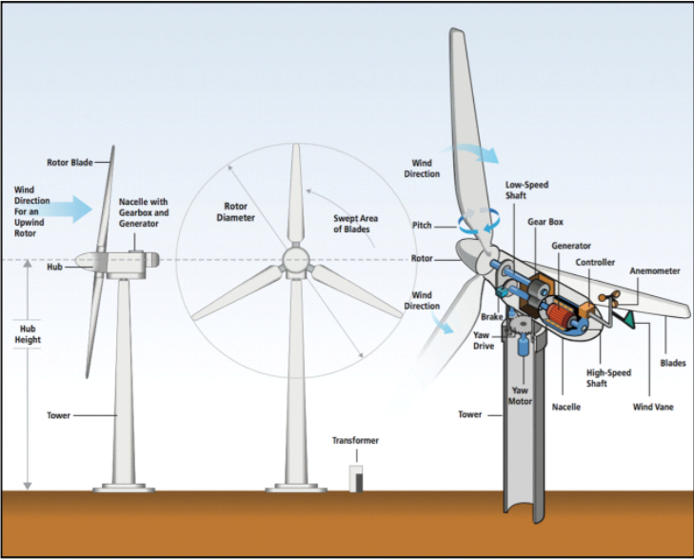

Figure2.1: Schematic overview of wind turbine

A typical wind turbine consists of the following components: the blades, which are typically manufactured from fiberglass-reinforced polyester or epoxy resin, though new materials are emerging; the nacelle, which is a protective housing that includes all the main components of the turbine; the rotor hub, which transfers the rotational energy to the rotor shaft; the gearbox, which converts the low-speed, high-torque rotation of the rotor to high-speed rotation with low-torque for input to the generator; the generator, which converts the mechanical energy from the rotor to electrical energy providing AC; the controller, which monitors the turbine and collects information so that the turbine constantly faces the wind; the tower, which can be made out of steel or concrete; and the transformers, which transform the electricity from the generator to meet the requirements of the grid (IEA, 2013, p. 7) [2].

The wind turbine mechanical output is related to the wind speed Vw and can be expressed as,

Pm =1/2ρ.A.Cp.Vw3

Where:  
Pm = Mechanical Power output

Cp = Maximum power coefficient  
ρ = Air density  
A = Rotor swept area  
Vw = Wind speed

The wind power captured by wind turbine depends on power

co-efficient (Cp) expressed as,

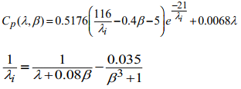

Here, λis the tip speed ratio and β is the blade pitch angle.

The value of λ can be calculated using the following relationship,



The amount of electricity that can be generated is proportional to the wind speed as the amount of kinetic energy increases with the cube of wind speed. That means that if wind speed doubles electricity output increases eight-fold. Additionally, the maximum output of a wind turbine is proportional to the swept area of the blades and the capacity of the turbine (IEA-ETSAP & IRENA, 2016, p. 8). These factors strongly influenced the design of modern wind turbines where the goal was to increase the height of the tower, the length of the blades, and the capacity of the turbine (IEA, 2013, p. 12; IEA-ETSAP & IRENA, 2016, p. 8)[2].

**2.2.1 Electricity Generation**

Wind power systems can roughly be distinguished by the orientation of their wind turbine, which can be horizontal or vertical, by their installation type, meaning whether or not they are realized on- or off-shore,; and by their grid-connection type(connected or standalone) where small-sized systems are usually standalone systems in remote areas (IEA-ETSAP & IRENA, 2016, p. 8). Horizontal-oriented turbines, which clearly dominate the utility-scale market, while vertical oriented turbines have a negligible share, and are fully commercial and mature, can further be distinguished by several technical aspects, such as the rotor type or placement (which can be up-wind or down-wind), the number of blades, the hub connection to the rotor, the gearbox design, and the wind turbine capacity (IRENA,2012b, p. 3).

Off-shore wind farms are more expensive than on-shore installations, but the come with the benefit of higher average wind speed at sea, thus higher potential efficiency.

Typically, overall generation efficiency of a modern wind power plant is between 42and 45% (Reuter &Elsner, 2016, p. 9). The capacity factor highly depends on the average wind speed at a given location. Hence, wind power plants in very windy locations with average wind speeds of about 10 m/s can achieve capacity factors of over 56%. However, these locations are mostly off-shore locations. For on-shore locations with lower wind speeds (6.2 m/s) capacity factors of 34% can be achieved (IEA, 2013, p. 12; Reuter &Elsner, 2016, p. 11) [1].

**2.2.2 Environmental and Social Impacts**

Wind energy has significant potential to reduce GHG emissions, together with the emissions of other air pollutants, by displacing fossil fuel-based electricity generation. Because of the relative maturity and cost of the technology, wind energy can be immediately deployed on a large scale enabling significant reductions in emissions in the short- to medium-term. As with other industrial activities, however, wind energy also has the potential to produce some negative impacts on the environment and on human beings, and many local and national governments have established planning, permitting, and siting requirements to minimize those impacts. These potential concerns need to be taken into account to ensure a balanced view of the advantages and disadvantages of wind energy. This section summarizes the best available knowledge on the most relevant environmental net benefits of wind energy, while also addressing more specifically ecological and human impacts, public attitudes and acceptance, and processes for minimizing social and environmental concerns [3].

**2.3 Wind Turbine Development and Types of Turbines**

Wind power as a source of green and abundant energy is proposed as one of the main new world power sources and has acquired a great momentum across the world. In the last few decades, wind turbines with different generators have been developed to increase the maximum power capture, minimize the cost, and expand the use of the wind turbines in both onshore and offshore applications [4].

**2.3.1 Wind Turbine History**

Wind power has been used for more than two thousand years; windmills were capturing wind power since 200bc using a constant speed rotor assembly. Wind power as a free, abundant, globally available, and green energy source is an obvious choice among all renewable energy sources for generation of electricity [4].

A screenshot of a cell phone

Description generated with high confidence

Figure 2.2: World’s cumulative installed wind power capacity during (1991-2012)

A screenshot of a cell phone

Description generated with very high confidence

Figure 2.3: Continents share of wind power capacity during 2002-2012

Figure 2.2 shows the world’s total cumulative installed wind power capacity between 1991 and 2012, and Figure 2.3 shows the shares of five continents in the total installed wind power capacity between 2002 and 2012. The average annual growth in the total installed wind power capacity in the last ten years has been 25% per year, and it is expected that the cumulative installed wind power capacity would pass400GW by 2015.It is also anticipated that 12% of the worlds electricity consumption will be provided by wind power by2020.

Europe has the most share of the total installed wind power capacity since 1997, with an increase from 4.6GW in 1997to more than 102GW in 2012. While Oceania and South America have the minimum wind power capacity increase from 2002 to 2012, the total installed capacity in Asia has a remarkable growth from 1.1GW in 1997 to more than100GW in 2012 that will make it the pioneer in the total installed wind power capacity, ahead of Europe in the following years.

A picture containing writing implement

Description generated with high confidence

Figure 2.4: Top 12 countries with the largest wind power capacities during 2007-2012

Figure.2.4 shows the top 12 countries in the world with the largest wind power capacities among more than 97 countries that use wind power on a commercial basis as of 2012. The significant growth in the total installed wind power capacity in Asia is mainly due to the rapid increase in the wind power capacity in China, which had an increase from5.9GW in 2007 to almost 76GW in 2012, with a considerable difference from the second ranked country, the United States of America (USA). While Germany still has the largest wind power capacity in Europe, there has been a very low rate of installed wind power capacity increase since 2007, compared with China and the USA, and it became the country with the third largest annual wind power capacity [4].

**2.3.2 Wind Turbine:**

Wind turbines operate on a simple principle. The energy in the wind turns two or three propeller-like blades around a rotor. The rotor is connected to the main shaft, which spins a generator to create electricity. A wind turbine works the opposite of a fan. Instead of using electricity to make wind, like a fan, wind turbines use wind to make electricity. The wind turns the blades, which spin a shaft, which connects to a generator and makes electricity [5].

**2.3.3 Types of Wind Turbines:**

There are two basic types of wind turbines:

1. Horizontal-axis turbines

2. Vertical-axis turbines

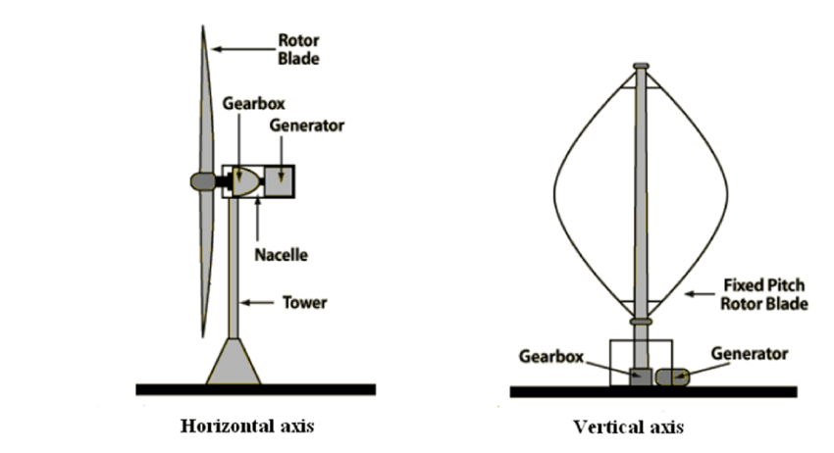Figure2.5: 2 types of Wind Turbines

The size of wind turbines varies widely. The length of the blades is the biggest factor in determining the amount of electricity a wind turbine can generate. Small wind turbines that can power a single home may have an electricity generating capacity of 10 kilowatts (kW). The largest turbines have generating capacities of 5,000 kW to 8,000 kW. Large turbines are often grouped together to create wind power plants, or wind farms, that provide power to electricity grids [7].

**Horizontal Axis Wind Turbine (HAWT)**

Horizontal-axis turbines have blades like airplane propellers, and they commonly have three blades. The largest horizontal-axis turbines are as tall as 20-story buildings and have blades more than 100 feet long. Taller turbines with longer blades generate more electricity. Nearly all of the wind turbines currently in use are horizontal-axis turbine [7].

Advantages

1. The tall tower base allows access to stronger wind in sites with wind shear. In some wind shear sites, every ten meters up the wind speed can increase by 20% and the power output by 34%.
2. High efficiency, since the blades always move perpendicularly to the wind, receiving power through the whole rotation. In contrast, all vertical axis wind turbines, and most proposed airborne wind turbine designs, involve various types of reciprocating actions, requiring airfoil surfaces to backtrack against the wind for part of the cycle. Backtracking against the wind leads to inherently lower efficiency [8].

Disadvantages

1. Massive tower construction is required to support the heavy blades, gearbox, and generator. Components of a horizontal axis wind turbine (gearbox, rotor shaft and brake assembly) being lifted into position.
2. HAWTs require an additional yaw control mechanism to turn the blades toward the wind. HAWTs generally require a braking or yawing device in high winds to stop the turbine from spinning and destroying or damaging itself [8].

Vertical-axis turbines

Vertical-axis turbines have blades that are attached to the top and the bottom of a vertical rotor. The most common type of vertical-axis turbine—the Darrieus wind turbine, named after the French engineer Georges Darrieus who patented the design in 1931—looks like a giant, two-bladed egg beater. Some versions of the vertical-axis turbine are 100 feet tall and 50 feet wide. Very few vertical-axis wind turbines are in use today because they do not perform as well as horizontal-axis turbines [7].

Advantages

1. No yaw mechanism is needed.
2. A VAWT can be located nearer the ground, making it easier to maintain the moving parts.
3. VAWTs have lower wind startup speeds than the typical the HAWTs.
4. VAWTs may be built at locations where taller structures are prohibited.
5. VAWTs situated close to the ground can take advantage of locations where rooftops, mesas, hilltops, ridgelines, and passes funnel the wind and increase wind velocity [8].

Disadvantages

1. Most VAWTs have an average decreased efficiency from a common HAWT, mainly because of the additional drag that they have as their blades rotate into the wind. Versions that reduce drag produce more energy, especially those that funnel wind into the collector area.
2. Having rotors located close to the ground where wind speeds are lower and do not take advantage of higher wind speeds above [8].

## **Chapter 3**

## **Artificial Neural Network 3.1 Introduction**

The simplest definition of a neural network, more properly referred to as an 'artificial' neural network (ANN), is provided by the inventor of one of the first neurocomputers, Dr. Robert Hecht-Nielsen. He defines a neural network as:

*"...a computing system made up of a number of simple, highly interconnected processing elements, which process information by their dynamic state response to external inputs.*

In "Neural Network Primer: Part I" by Maureen Caudill, AI Expert, Feb. 1989.

Artificial neural networks (ANNs) are biologically inspired computer programs designed to simulate the way in which the human brain processes information. ANNs gather their knowledge by detecting the patterns and relationships in data and learn (or are trained) through experience, not from programming. An ANN is formed from hundreds of single units, artificial neurons or processing elements (PE), connected with coefficients (weights), which constitute the neural structure and are organized in layers. The power of neural computations comes from connecting neurons in a network. Each PE has weighted inputs, transfer function and one output. The behavior of a neural network is determined by the transfer functions of its neurons, by the learning rule, and by the architecture itself. The weights are the adjustable parameters and, in that sense, a neural network is a parameterized system. The weighed sum of the inputs constitutes the activation of the neuron. The activation signal is passed through transfer function to produce a single output of the neuron. Transfer function introduces non-linearity to the network. During training, the inter-unit connections are optimized until the error in predictions is minimized and the network reaches the specified level of accuracy. Once the network is trained and tested it can be given new input information to predict the output. Many types of neural networks have been designed already and new ones are invented every week but all can be described by the transfer functions of their neurons, by the learning rule, and by the connection formula. ANN represents a promising modeling technique, especially for data sets having non-linear relationships which are frequently encountered in pharmaceutical processes. In terms of model specification, artificial neural networks require no knowledge of the data source but, since they often contain many weights that must be estimated, they require large training sets. In addition, ANNs can combine and incorporate both literature-based and experimental data to solve problems. The various applications of ANNs can be summarized into classification or pattern recognition, prediction and modeling [9].

### **3.2 Historical background**

The history of neural networks that was described above can be divided into several periods:

1. **First Attempts:**

There were some initial simulations using formal logic. McCulloch and Pitts (1943) developed models of neural networks based on their understanding of neurology. These models made several assumptions about how neurons worked. Their networks were based on simple neurons, which were considered binary devices with fixed thresholds. The results of their model were simple logic functions such as "a or b" and "a and b". Another attempt was by using computer simulations9. Two groups (Farley and Clark, 1954; Rochester, Holland, Haibit and Duda, 1956). The first group (IBM researchers) maintained closed contact with neuroscientists at McGill University. Therefore, whenever their models did not work, they consulted the neuroscientists. This interaction established a multidisciplinary trend, which continues to the present day [10].

1. **Promising & Emerging Technology:**

Neuroscience not only was influential in the development of neural networks, but psychologists and engineers also contributed to the progress of neural network simulations. Rosenblatt (1958) stirred considerable interest and activity in the field when he designed and developed the Perceptron. The Perceptron had three layers with the middle layer known as the association layer. This system could learn to connect or associate a given input to a random output unit. Another system was the ADALINE (Adaptive Linear Element) which was developed in 1960 by Widrow and Hoff (of Stanford University). The ADALINE was an analogue electronic device made from simple components. The method used for learning was different to that of the Perceptron; it employed the Least-Mean-Squares (LMS) learning rule[10].

1. **Period of Frustration & Disrepute:**

In 1969 Minsky and Paper wrote a book in which they generalized the limitations of single layer Perceptions to multilayered systems. In the book, they said: "...our intuitive judgment that the extension (to multilayer systems) is sterile". The significant result of their book was to eliminate funding for research with neural network simulations. The conclusions supported the disenchantment of researchers in the field. As a result, considerable prejudice against this field was activated.

1. **Innovation:**

Although public interest and available funding were minimal, several researchers continued working to develop neuromorphic ally based computational methods for problems such as pattern recognition.   
During this period several paradigms were generated which modern work continues to enhance. Grossberg’s (Steve Grossberg and Gail Carpenter in 1988) influence founded a school of thought, which explores resonating algorithms. They developed the ART (Adaptive Resonance Theory) networks based on biologically plausible models. Anderson and Kohonen developed associative techniques independent of each other. Klopf (A. Henry Klopf) in 1972 developed a basis for learning in artificial neurons based on a biological principle for neuronal learning called heterostasis.   
Werbos (Paul Werbos 1974) developed and used the back-propagation learning method, however several years passed before this approach was popularized. Back-propagation nets are probably the most well-known and widely applied of the neural networks today. In essence, the back-propagation net. is a Perceptron with multiple layers, a different threshold function in the artificial neuron, and a more robust and capable learning rule. Amari (A. Shun-Ichi 1967) was involved with theoretical developments: he published a paper which established a mathematical theory for a learning basis (error-correction method) dealing with adaptive pattern classification. While Fukushima (F. Kunihiko) developed a step, wise trained multilayered neural network for interpretation of handwritten characters. The original network was published in 1975 and was called the Cognition.   
  
**5. Re-Emergence:**

Progress during the late 1970s and early 1980s was important to the re-emergence on interest in the neural network field. Several factors influenced this movement. For example, comprehensive books and conferences provided a forum for people in diverse fields with specialized technical languages, and the response to conferences and publications was quite positive. The news media picked up on the increased activity and tutorials helped disseminate the technology. Academic programs appeared and courses were introduced at most major Universities (in US and Europe). Attention is now focused on funding levels throughout Europe, Japan and the US and as this funding becomes available, several new commercial with applications in industry and financial institutions are emerging.

1. **Today:**

Significant progress has been made in the field of neural networks-enough to attract a great deal of attention and fund further research. Advancement beyond current commercial applications appears to be possible, and research is advancing the field on many fronts. Neutrally based chips are emerging and applications to complex problems developing. Clearly, today is a period of transition for neural network technology.

##### **3.3 Mechanism of ANN**

ANNs are composed of multiple nodes, which imitate biological neurons of human brain. The neurons are connected by links and they interact with each other. The nodes can take input data and perform simple operations on the data. The result of these operations is passed to other neurons. The output at each node is called its activation or node value [11].

Each link is associated with weight. ANNs are capable of learning, which takes place by altering weight values.

There are three different layers in a neural network: -

1. Input Layer (All the inputs are fed in the model through this layer)
2. Hidden Layers (There can be more than one hidden layers which are used for processing the inputs received from the input layers)
3. Output Layer (The data after processing is made available at the output layer)

Following is the manner in which these layers are laid-

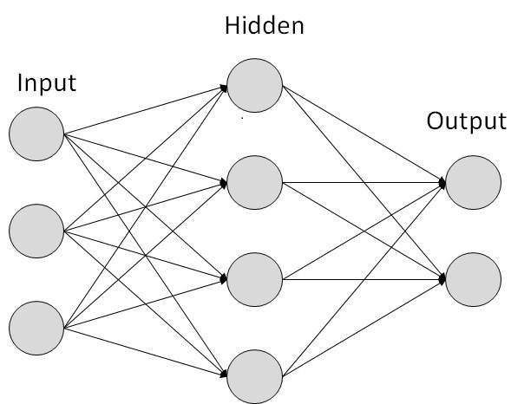

Figure 3.1: Depicting the different layers of a neural network

Input Layer

The Input layer communicates with the external environment that presents a pattern to the neural network. Its job is to deal with all the inputs only. This input is transferred to the hidden layers, which are explained below. The input layer should represent the condition for which we are training the neural network. Every input neuron should represent some independent variable that has an influence over the output of the neural network

Hidden Layer

The hidden layer is the collection of neurons, which has activation function applied on it, and it is an intermediate layer found between the input layer and the output layer. Its job is to process the inputs obtained by its previous layer. Therefore, it is the layer, which is responsible extracting the required features from the input data. Many researches has been made in evaluating the number of neurons in the hidden layer but still none of them was successful in finding the accurate result. In addition, there can be multiple hidden layers in a Neural Network. Suppose that if we have a data, which can be separated linearly, then there is no need to use hidden layer as the activation function can be implemented to input layer, which can solve the problem. However, in case of problems, which deals with complex decisions, we can use 3 to 5 hidden layers based on the degree of complexity of the problem or the degree of accuracy required. That certainly not means that if we keep on increasing the number of layers, the neural network will give high accuracy! A stage comes when the accuracy becomes constant or falls if we add an extra layer! In addition, we should also calculate the number of neurons in each network. If the number of neurons are less as compared to the complexity of the problem data then there will be very few neurons in the hidden layers to adequately detect the signals in a complicated data set. If unnecessary more neurons are present in the network then Overfitting may occur. Several methods are used till now which do not provide the exact formula for calculating the number of hidden layer as well as number of neurons in each hidden layer.

Output Layer

The output layer of the neural network collects and transmits the information accordingly in way it has been designed to give. The pattern presented by the output layer can be directly traced back to the input layer. The number of neurons in output layer should be directly related to the type of work that the neural network was performing. To determine the number of neurons in the output layer, first consider the intended use of the neural network [12].

Following is the concise framework in which artificial neural networks (ANN) work: [13]

[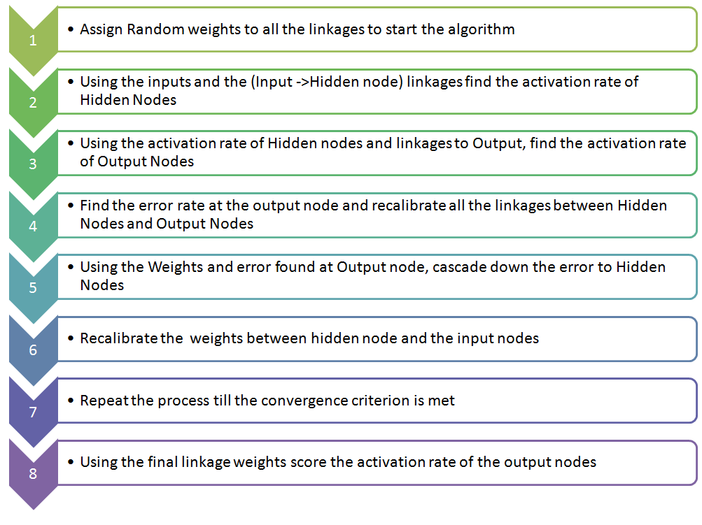](https://www.analyticsvidhya.com/blog/wp-content/uploads/2014/10/flowchart-ANN.png)

**3.4 Advantages of Artificial Neural Networks (ANN)**

► Storing information on the entire network: Information such as in traditional programming is stored on the entire network, not on a database. The disappearance of a few pieces of information in one place does not prevent the network from functioning.

►Nonlinear data processing: Nonlinear systems have the capability of finding shortcuts to reach computationally expensive solutions. These systems can also infer connections between data points, rather than waiting for records in a data source to be explicitly linked. This nonlinear short-cut mechanism is fed into artificial neural networking, which makes it valuable in commercial big-data analysis [14].

► Ability to work with incomplete knowledge:  After ANN training, the data may produce output even with incomplete information. The loss of performance here depends on the importance of the missing information.

► Having fault tolerance:  Corruption of one or more cells of ANN does not prevent it from generating output. This feature makes the networks fault tolerant.

► Having a distributed memory: In order for ANN to be able to learn, it is necessary to determine the examples and to teach the network according to the desired output by showing these examples to the network. The network's success is directly proportional to the selected instances, and if the event cannot be shown to the network in all its aspects, the network can produce false output

► Gradual corruption:  A network slows over time and undergoes relative degradation. The network problem does not immediately corrode immediately.

► Ability to make machine learning: Artificial neural networks learn events and make decisions by commenting on similar events.

► Parallel processing capability:  Artificial neural networks have numerical strength that can perform more than one job at the same time.

►Self-repair: Artificial neural networks can do more than routing around parts of the network that no longer operate. If they are asked for finding out specific data that is no longer communicating, these artificial neural networks can regenerate large amounts of data by inference and help in determining the node that is not working. This trait is useful for networks that require informing their users about the current state of the network and effectively results in a self-debugging and diagnosing network.

Scientists are now trying to understand capacities, assumptions, and applicability of various approaches that can significantly improve the performance of artificial neural networking systems.

►Unlike many other prediction techniques, ANN does not impose any restrictions on the input variables (like how they should be distributed). Additionally, many studies have shown that ANNs can better model heteroscedasticity i.e. data with high volatility and non-constant variance, given its ability to learn hidden relationships in the data without imposing any fixed relationships in the data. This is something very useful in financial time series forecasting (e.g. stock prices) where data volatility is very high.

**3.5 Applications of neural networks**

**1. Character Recognition** - The idea of character recognition has become very important as handheld devices like the Palm Pilot are becoming increasingly popular. Neural networks can be used to recognize handwritten characters.

**2. Image Compression** - Neural networks can receive and process vast amounts of information at once, making them useful in image compression. With the Internet explosion and more sites using more images on their sites, using neural networks for image compression is worth a look.

**3. Speech Recognition**- Speech Recognition could be obtained by analyzing audio oscilloscope pattern. Traffic flows could be predicted so that signal timing could be optimized.

**4. Human Face Recognition** - It is one of the biometric methods to identify the given face. It is a typical task because of the characterization of “non-face” images. However, if a neural network is well trained, then it can be divided into two classes namely images having faces and images that do not have faces.

**5. Signature Verification Application** - For this task, we have to train the neural networks using an efficient neural network algorithm. This trained neural network will classify the signature as being genuine or forged under the verification stage.

**6. Traveling Salesman's Problem** - Interestingly enough, neural networks can solve the traveling salesman problem, but only to a certain degree of approximation.

**7. Medical Or Biomedical Technology -** Used in EEG, ECG analysis, cancer cell analysis.

**8. Electronics** - ANN can be use in chip failure analysis, Ic chip layout, voice synthesis.

**9. Control system** - ANN have been applied very successfully in the identification and control of dynamic system and in intelligent modeling and identification of aircraft nonlinear flight [15].

Chapter 4

**Feed Forward Back Propagation process**  
**4.1 Neural Network Structure**

The way in which the neurons of a neural network are interconnected determines its structure. For the purposes of identification and control, the most used structures are as follows:

I. Single-layer feed-forward networks.

2. Multilayer feed-forward networks.

3. Radial basis networks.

4. Dynamic (differential) or recurrent neural networks.

**4.1.1 Single-layer Feed-forward Networks**

It is the simplest form of feed-forward networks. It has just one layer of neurons as shown in. The best known is the so-called perceptron. It consists of a single neuron with adjustable synaptic weights and threshold.

**­­­­­­­­4.1.2 Multilayer Feed-forward Neural Networks**

They distinguish themselves by the presence of one or more hidden layers whose computation nodes are called hidden neurons. Typically, the neurons in each layer have the output signals of the preceding layer as their inputs. If each neuron in each layer is connected to every neuron in the adjacent forward layer, then the neural network is named as fully connected, on the opposite case, it is called partly connected.

**4.1.3 Radial Basis Function Neural Networks**

Radial basis function (RBF) neural networks have three entirely different. 1. The input layer made up of input nodes. 2. The hidden layer, with a high enough number of nodes (neurons). Each of these nodes performs a nonlinear transformation of the input, by means of radial basis functions. 3. The output layer, which is a linear combination of the hidden inputs neurons. Radial basis functions were first introduced for the solution of multivariate interpolation problems; early works on this approach are surveyed in. The first application of radial basis functions to neural networks design is reported in.

**4.1.4 Recurrent Neural Networks**

A common approach for encoding temporal information using static neural networks is to include delaying inputs and outputs. However, this representation is limited, since it can only encode a finite number of the previous measured outputs and imposed inputs; moreover, it tends to require prohibitively large amounts of memory, thereby hindering its use for all but relatively low order dynamical systems. As a very efficient and promising alternative, the international research community has been exploring the use of recurrent or dynamic neural networks. Recurrent or dynamic neural networks distinguish themselves from static neural networks in which they have at least one feedback loop. One of the first surveys of structures, learning algorithms and applications of this kind of neural networks is given in. There, it is signaled that neural networks, whose structures include feedback, are present from the very earliest development of artificial neural networks; in fact, McCul-loch and Pitts developed models for feed-forward networks, which have time dependence and time delays; however, these networks were implemented with threshold logic neurons. Then, they extended their network to those with dynamic memory; these networks had feedback. Later, these networks were modeled as finite automata with a regular language in, which is usually referenced as the first work on this kind of automata.

**4.2 Multilayer feed forward system**

In the Multi-Layer system structure, the neurons are grouped into layers. The first and last layers are called input and output layers respectively, because they represent inputs and outputs of the overall network. The remaining layers are called hidden layers. Typically, an MLP neural network consists of an input layer, one or more hidden layers, and an output layer, as shown in Figure

A close up of text on a white background

Description generated with high confidence

Fig 4.1: Multi-Layer system

**4.3Multi Layer Feed Forward Process**

A Feed Forward network is a non-recurrent network, which contains inputs, outputs, and hidden layers; the signals can only travel in one direction. Input data is passed onto a layer of processing elements where it performs calculations. Each processing element makes its computation based upon a weighted sum of its inputs

The new calculated values then become the new input values that feed the next layer. This process continues until it has gone through all the layers and determines the output. A threshold transfer function is sometimes used to quantify the output of a neuron in the output layer

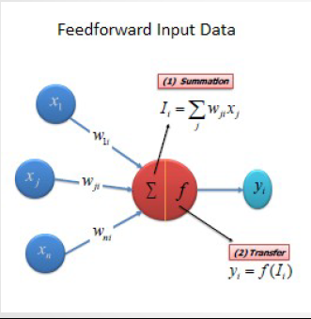

Fig 4.2: Feed Forward Process

**4.4 Transfer (Activation) Function**  
The transfer function translates the input signals to output signals. Hence, it influences the behavior of an ANN.

Four types of transfer functions are commonly used; they are  
1.Unit step (threshold).  
2. Piecewise linear.  
3. Sigmoid.  
4. Gaussian.

We are using sigmoid as transfer (Activation) function.

**4.4.1 Sigmoid function**  
the sigmoid function consists of two functions, logistic and tangential. The values of logistic function range from zero and one and -1 to +1 for tangential function

We are using the logistic function. The Sigmoid Function Equation is shown below

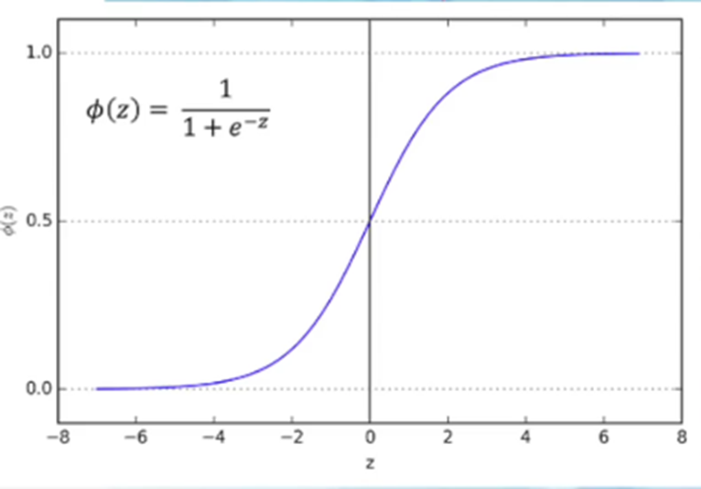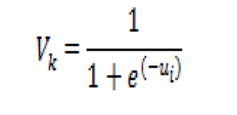

Figure 4.3: Sigmoid Function Graph (showing range)

**4.5 Back propagation process**

In Back Propagation system we use output error, to adjust the weights of inputs at the output layer.

We can also calculate the error at the previous layer, and use it to adjust the weights arriving there, we repeat this process of back-propagating errors through any number of layers.

This is made possible by using a sigmoid as the non-linear transfer function, sigmoid is used because it is differentiable.

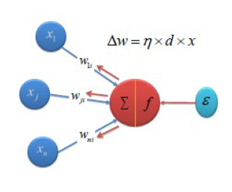  
  
Figure 4.4: Back propagation system

**4.6 Gradient Descent Method**Now, using the gradient descent function weights are updated by minimization of the sum of the squared error.

From the non-linear function, we can find this relation between the error and the random values of the weight.

We can see from the graph that higher or lower the weight value, error rises significantly. Therefore, we want find the lowest point, which has the minimum error.

A close up of a sign

Description generated with high confidence

Figure 4.5: Error VS Random weight order graph

**4.6.1 Gradient Descent Method Adjusting weights using derivative method**

We will use the derivative to get to the minimum error.  
Derivative is the term that means the slope of the tangent line to a curve at a specific point.

Derivative of a function gives another function that returns the slopes of the point at any point of x.

A close up of a logo

Description generated with very high confidence

A close up of a screen

Description generated with high confidenceFigure 4.6: Derivative Method

Figure 4.7: Derivative Method

We have to go descending the gradient will eventually the weight will find the minimum of the error

A picture containing sky

Description generated with very high confidence. Figure 4.8: Gradient Descent method using Derivative

**4.6.2 Adjusting weights**  
  
Now we have to adjust the weights.

A picture containing object

Description generated with very high confidence  
  
Here is the rate of change of error that is being calculated by gradient descent method where 𝜂 is the learning rate.  
𝜂 will always be between 0 to 1.

A picture containing object

Description generated with very high confidence  
From the equation, we can see that the weights are continuously updated. We are getting the new weights by adding the gradient to the old weights. The equation of finding the new weight values is given below:

**Chapter 5**

**Implementation of ANN algorithm**

**5.1 Wind Velocity Estimation by ANN 1**

In this scheme, sample data turbine power (Pm) is produced from turbine power equation with rotor speed (ωr) and wind velocity (Vw) samples. The rotor speed (ωr) and power (Pm) samples are employed as input matrix of the neural network 1. On the other hand, the wind velocity (Vw) sample are used as target to train the network 1 as shown in Figure 5.1 which is configured with two linear neurons in the input layer, ten sigmoid neurons in the hidden layer, and one linear neuron in the output layer.

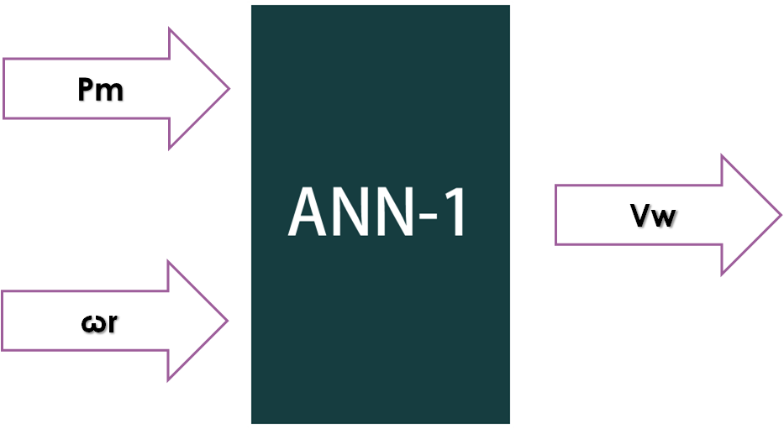

Figure 5.1: Wind velocity estimation by ANN 1

**5.2 Estimated wind speed determination**

Mechanical sample power P„, and preselected rotor speed (Ꙍr) are imported to an nntool as an input data and wind speed Vw as an output data. By selecting input and output data and training algorithm, nntool creates a neural network. This neural network is exported from nntool and creates a matrix. Then using a MATLAB coding, it is possible to determine estimated wind speed. Thus, estimated wind speed is created which is used to determine the error of wind speed estimation.

**5.3 Optimal rotor speed Estimation by ANN 2**

In this scheme, optimal rotor speed (Ꙍr*) for maximum power point and wind velocity (Vw) are samples. wind velocity (Vw) is employed as input (2×1) matrix of the neural network2. On the other hand, optimal rotor speed (Ꙍr*) samples are used as target to train the network2 as shown in Figure 5.2 which is configured with two linear neurons in the input layer, ten sigmoid neurons in the hidden layer, and one linear neuron in the output layer.

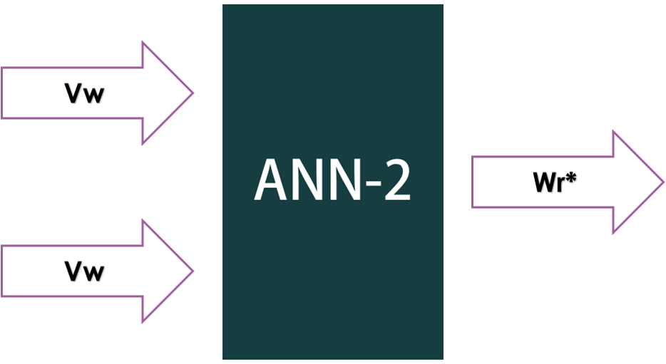

Figure 5.2: optimal rotor speed estimation by ANN 2

**5.4 Estimate optimal rotor speed determination**

Wind velocity (Vw) is imported to an nntool as an input data and optimal rotor speed (Ꙍr*) as an output data. By selecting input and output data and training algorithm, nntool creates a neural network. This neural network is exported from nntool and creates a matrix. Then using a MATLAB coding, it is possible to determine estimated optimal rotor speed (Ꙍr*). Thus estimated optimal rotor speed (Ꙍr*) is created which is used to determine the error of optimal rotor speed (Ꙍr*).

**5.5 Final implementation**

In this study two series networks are used for ANN based MPPT as shown in Fig.5.3. Based on the operating turbine power and rotor speed, network-1 estimates the wind speed. The estimated wind speed input for network-2 is used to determine optimal rotor speed. Estimated optimal rotor speed extracts the maximum power.

**ANN1**

**Pm**

**ωr**

**Wr\***

**Vw**

**ANN2**

Figure 5.3: Proposed ANN based MPPT controller

**5.6 Regression Analysis of ANN 1**

We had imported two input data (Power, Pm and rotor speedꙌr) and one target data ( wind speed, Vw) into an nntool which created a neural network. Then we had set all the input and output data into the nntool. There were two layers, ten neurons and the transfer function was sigmoid. After training our data, we found the regression result as shown in figure-5.4.

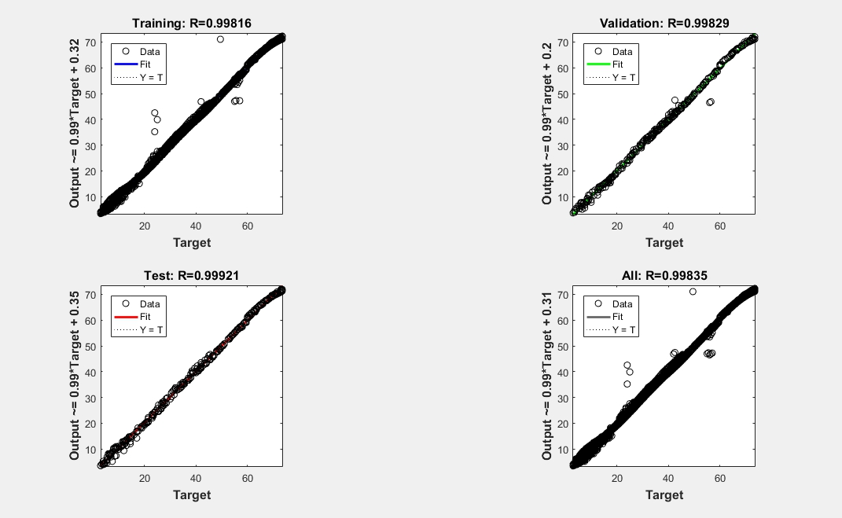

Figure-5.4: Regression Analysis of ANN 1

Here number-1 is for training set, number-2 is for validation set, number-3 is for resting set and number-4 is for the all. The values of training set, validation stand testing set am tends to one which indicate that the error is minimum. Thus, this mat proves that our approximate desired result is attained.

**5.7 Regression Analysis of ANN 2**

We had imported two same input data (wind speed, Vw) and one target data (optimal rotor speed, Ꙍr*) into annntool which created a neural network. Then we had set all the input and output data into the nntool. There were two layers, ten neurons and the transfer function was sigmoid. After training our data, we found the regression result as shown in figure-

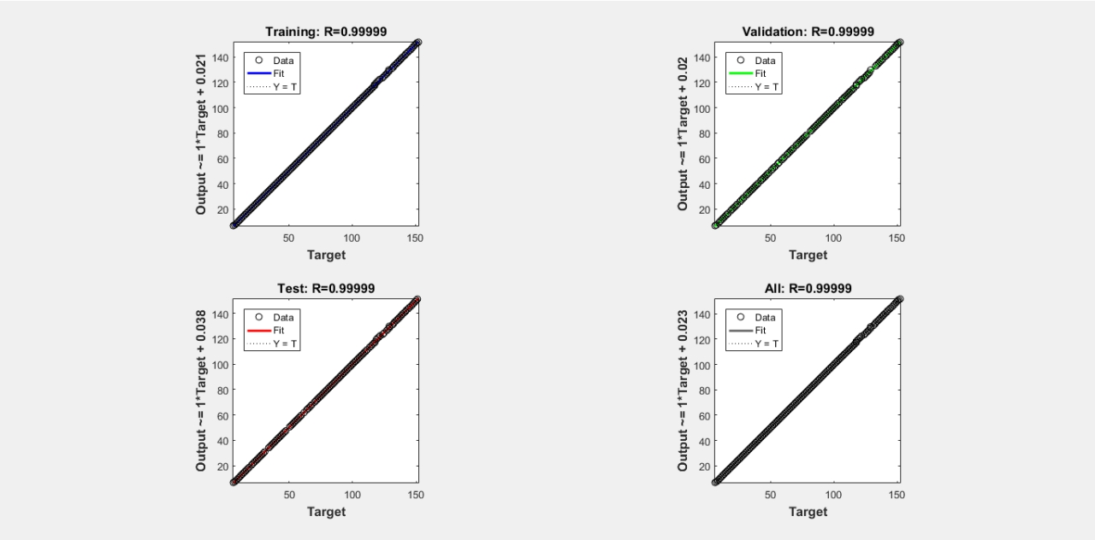

Figure-5.5: Regression Analysis of ANN 2

**5.8 Validation performance**

This figure-5.6 illustrates the mean squared error and epochs that determine training, validation and test data. From this figure-5.6, it can be seen that the best validation performance is 0.032697 at epoch 530.

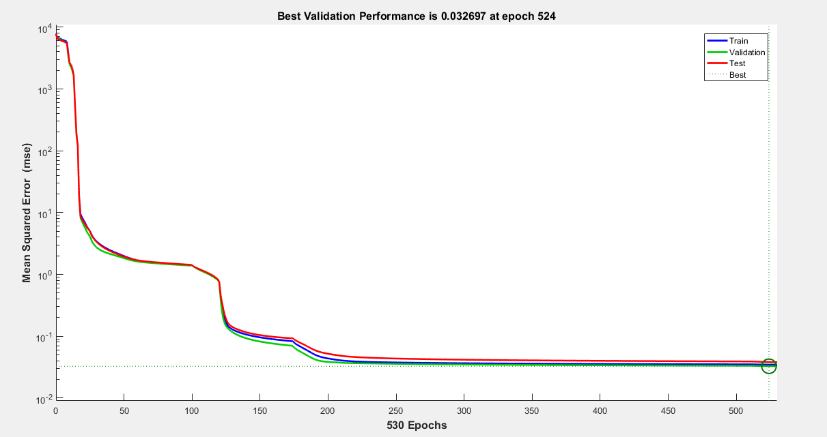

Figure-5.6: Validation performance

* Epoch

It means iteration that indicates one forward path and one backward path of all our training data.

The blue line from the figure indicates the training set.

* Training set

It is used to adjust the weight of the neural network.

The green line indicates the validation set.

* Validation set

It is used to minimize over fitting. It is not adjusting the weights of the network with data sets and the red line indicates the testing set.

* Testing set

It is used for testing the final solution of the neural network. It ensures the at predictive power of the network.

Therefore, from the figure we can say that, the training, validation and testing are tends to the best fitting curve.

**Chapter 6**

**Results and Discussions**

**6.1 Wind speed Estimation under Rapidly Changing wind conditions**

The ANN developed in this study using two series networks was tested for given wind speed profile shown in Fig 6(a). The blue solid lines show the given (original) speed and the neural network output is represented by the red lines. It can be seen that the predicted wind speed variation completely overlaps the original one.

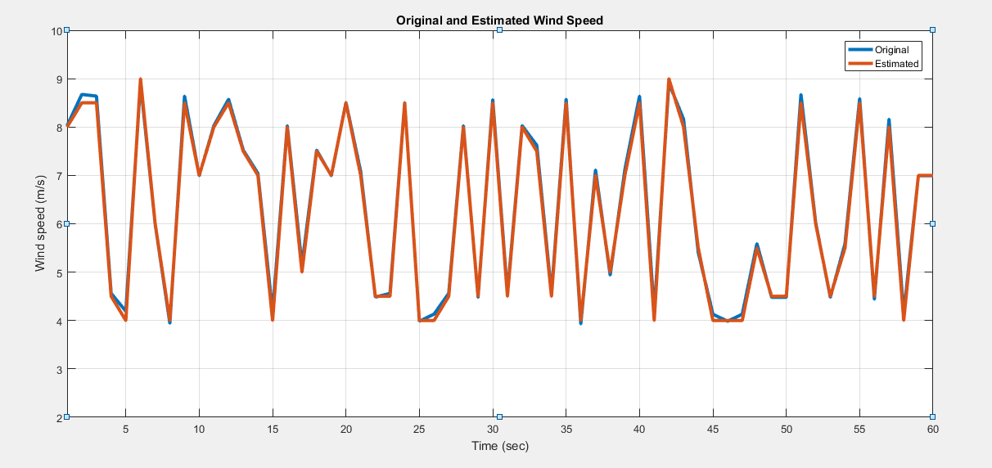Figure6.1: Original and estimated wind speed

**6.2 Wind speed Error**

Error=Original (op)-Estimated (z)

In Fig.6(b), simulation result shows the error in wind speed estimation for ANN based wind speed estimator. It can be noticed from the graph that the wind velocity is well estimated with small errors, the maximum error is only 0.18 m/s.

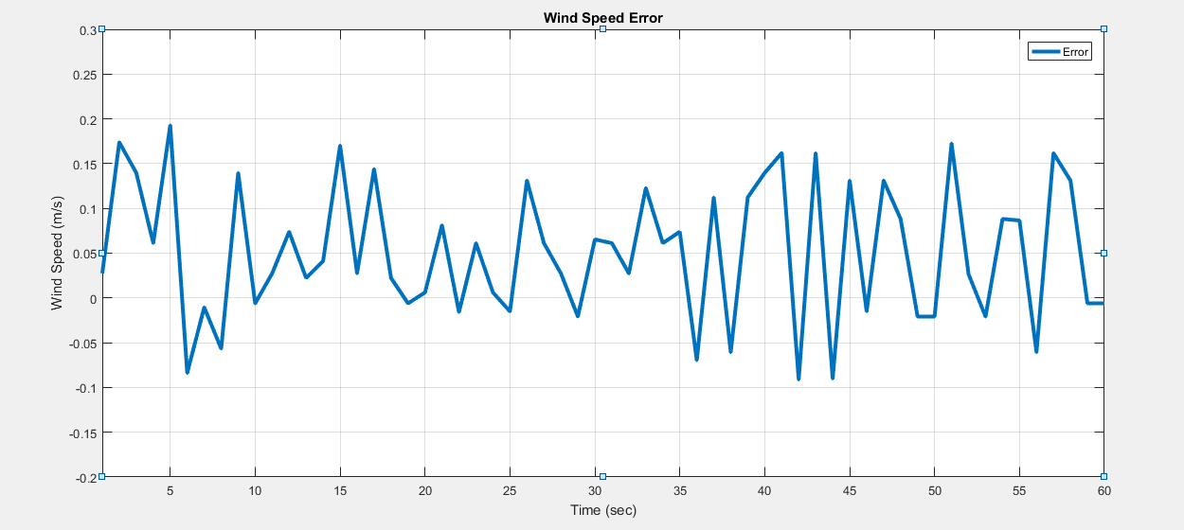

Figure6.2: wind speed error

The above figure indicates less wind speed estimation error that denotes successful training operation.

**6.3 Optimal Rotor speed Estimation**

Fig.6(c) shows the original and estimated optimal rotor speeds. The given (original) speed is shown by the blue solid lines and the neural network output is represented by the red lines. It can be seen that the predicted wind speed variation completely overlaps the original one.

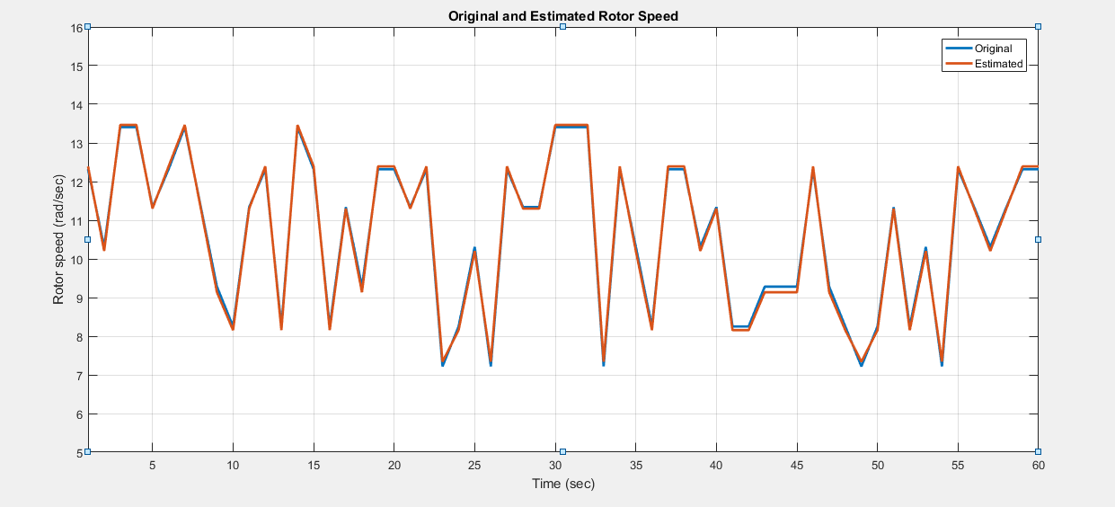

Figure6.3: Original and Estimated Rotor speed

**6.4 Rotor speed error**

Error=Original(op)-Estimated(z)

Fig.6(d) shows the errors in optimal rotor speed estimation. The results, demonstrates that the proposed MPPT controller has the ability to track optimal rotor speed efficiently under rapidly changing wind conditions. The maximum error is only .14 rad/sec.

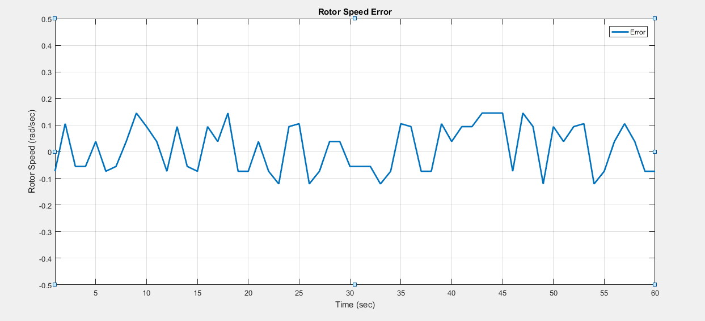

Figure6.4: Rotor speed error

The above figure indicates less optimal rotor speed estimation error that denotes successful training operation.

**Chapter 7**

* 1. **Conclusion**

A sensor -less wind speed estimation and optimal rotor speed estimation using artificial neural network is presented. In the study two series networks are used for ANN based MPPT. Based on the operating turbine power and rotor speed, network-1 estimates the wind speed. The estimated wind speed input for network-2 is used to determine optimal rotor speed. Estimated optimal rotor speed extracts the maximum power of wind energy. The method has the following features.

* Wind speed can be estimated under rapidly changing wind condition.
* Optimal rotor speed can be estimated for any particular wind speed.

The obtained result demonstrate that the system shows better performance to extract maximum power.

**References:**

1. Renewable Energy and Electricity: <http://www.world-nuclear.org/information-library/energy-and-the-environment/renewable-energy-and-electricity.aspx>
2. SCHINKE B., KLAWITTER J., DÖRING M., KOMENDANTOVA N., IRSHAID J., “ Energy Planning for Sustaining Development in the Mena Region’’ , Mena Select working paper , pp. 143-145 , February. 2017 .
3. Ryan Wiser, Zhenbin Yang, “ Special Report Renewable Energy Sources (SRREN)”, Chapter 7: Wind energy : Environmental and social impacts , pp.39, IPCC, Dec. 2009 : <https://www.ipcc.ch/pdf/special-reports/srren/drafts/SRREN-FOD-Ch07.pdf>
4. N. Goudarzi· W. D. Zhu , “A review on the development of wind turbine generators across the world”, pp.192-194, [International Journal of Dynamics and Control](https://link.springer.com/journal/40435)(IJDC), June.2013 .
5. How do wind turbine work : <https://www.energy.gov/eere/wind/how-do-wind-turbines-work>
6. Advantages of wind power : <https://www.energy.gov/eere/wind/advantages-and-challenges-wind-energy>
7. Types Of Wind Turbine: https://www.eia.gov/energyexplained/index.cfm?page=wind_types_of_turbines
8. Types of Wind Turbines : http://centurionenergy.net/types-of-wind-turbines
9. Basic concepts of artificial neural network (ANN) modeling and its application in pharmaceutical research: <https://doi.org/10.1016/S0731-7085(99)00272-1>
10. NEURAL NETWORKS by Christos Stergiou and Dimitrios Siganos Appendix A - Historical background in detail: <https://www.doc.ic.ac.uk/~nd/surprise_96/journal/vol4/cs11/report.html#Appendix%20A%20-%20Historical%20background%20in%20detail>
11. Artificial Intelligence - Neural Networks → Basic Structure of ANNs: <https://www.tutorialspoint.com/artificial_intelligence/artificial_intelligence_neural_network.htm>
12. Artificial Neuron Networks (Basics) | Introduction to Neural Networks: <https://becominghuman.ai/artificial-neuron-networks-basics-introduction-to->neural-networks-3082f1dcca8c
13. How does Artificial Neural Network (ANN) algorithm work? Simplified! Formulation of Neural network: <https://www.analyticsvidhya.com/blog/2014/10/ann-work-simplified/>
14. Artificial Neural Networks Advantages and Disadvantages by Maad M. Mijwel: <https://www.linkedin.com/pulse/artificial-neural-networks-advantages-disadvantages-maad-m-mijwel/>
15. Neural networks: <https://cs.stanford.edu/people/eroberts/courses/soco/projects/neural-networks/Applications/index.html>
16. How a wind turbine works: <https://www.energymatters.com.au/components/wind-energy/>
17. Advantages and disadvantages of wind energy: <https://www.clean-energy-ideas.com/wind/wind-energy/advantages-and-disadvantages-of-wind-energy/>
18. Advantages and challenges of wind energy: <https://www.energy.gov/eere/wind/advantages-and-challenges-wind-energy/>
19. How much do wind turbines cost: <http://www.windustry.org/how_much_do_wind_turbines_cost7>
20. How loud is a wind turbine: <https://www.ge.com/reports/post/92442325225/how-loud-is-a-wind-turbine/>
21. Wind turbine Tip Speed Ratio: <http://www.reuk.co.uk/wordpress/wind/wind-turbine-tip-speed-ratio/>
22. Maximum power point tracking: <https://en.m.wikipedia.org/wiki/Maximum_power_point_tracking>
23. Artificial neural network: https://en.m.wikipedia.org/wiki/Artificial_neural _network
24. Artificial intelligence-fuzzy logic systems: https://www.tutorialspoint.com/artificial_intelligence/artificial_intelligence_fuzzy_logic_systems.html

.